Eric Zorn

9.24.17

ICT 4300

Professor/Dr. Lakhani

**Eric Zorn – Module 3 ICT 4300 Homework Questions 1 & 2**

Question 1 (Use Case Diagram):

|  |  |
| --- | --- |
| Use Case ID: | 1 |
| Use Case Name: | Order Food |
| Actors: | Patron, Waiter, Chef, Cashier, Bar Tender |
| Description: | A Patron places an order for food using a Waiter. The waiter then delivers the order to the kitchen and brings food back to the table. The waiter can also take orders from the patron for drinks, which the bar tender will make. Finally, the order is cashed out from the register and the check is brought to the table. The patron will pay the waiter and then the money and the check will be brought back to the cashier and the register. The cashier will collect the money and the receipt and the patron will have completed the entire meal and then leave after the money is fully processed. |
| Preconditions: | 1. Patron is in the restaurant. 2. Waiter is available to take the order. 3. Chef has an open stove/oven to start cooking food 4. Chef has the proper ingredients for the order 5. There is money in the register to return in the register 6. A cashier is present at the register 7. Bar tender is at the bar 8. Bar tender has proper alcohol or soda available |
| Post conditions: | 1. Food is served to the Patron. 2. Drink is served to the Patron 3. Patron has paid |
| Normal Flow: | * 1. **Order Food**      1. Patron arrives in a restaurant      2. Patron views menu      3. Patron selects one or more items from menu      4. Waiter notes the food item(s) selected by Patron      5. Patron indicates that Food Order is complete      6. Waiter brings food order to the kitchen      7. After Chef is done, Waiter brings food to the table   2. **Order Drink**      1. Patron has entered the restaurant      2. Patron has been handed drink menu or both food and drink menu      3. Patron selects one or more drinks from the menu      4. Patron indicates that Drink Order is complete      5. Waiter notes the drink item(s) selected by Patron      6. Waiter brings order to the bar tender      7. When the bar tender is done with drink, waiter brings drink to table   3. **Food Cooked**      1. Chef receives order from the waiter      2. Chef finds ingredients      3. Chef prepares ingredients (washes, slices, measures)      4. Chef mixes ingredients      5. Chef cooks ingredients      6. When meal is finished, chef signals waiter      7. Waiter brings food to the Patron’s table   4. **Drink Mixed**      1. Bar tender receives drink order from waiter      2. Bar tender finds proper alcohol or soda beverages      3. Bar tender measures beverages      4. Bar tender mixes beverages      5. Final Beverage is poured into glass      6. Bar tender signals waiter      7. Waiter brings beverage(s) to the Patron’s Table   5. **Meal is Paid**      1. Patron eats and drinks food and beverage      2. Patron finishes meal      3. Patron signals waiter      4. Patron asks waiter for check      5. Waiter goes to Cashier      6. Cashier prints receipt      7. Cashier hands receipt to Waiter      8. Waiter brings receipt to Patron’s table      9. Patron views bill      10. Patron calculates total      11. Patron places cash on table, including the tip      12. Patron hands money and receipt to waiter      13. Patron leaves      14. Waiter returns with money and receipt to the Cashier      15. Cashier takes money and receipt from waiter      16. Cashier hands tip to waiter      17. Meal is complete and paid for by the patron      18. Cashier receives money from the waiter      19. Patron leaves and the money with the receipt it stored away |

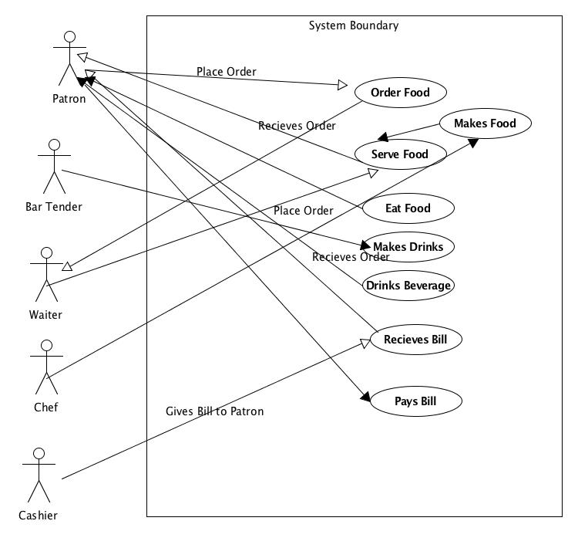

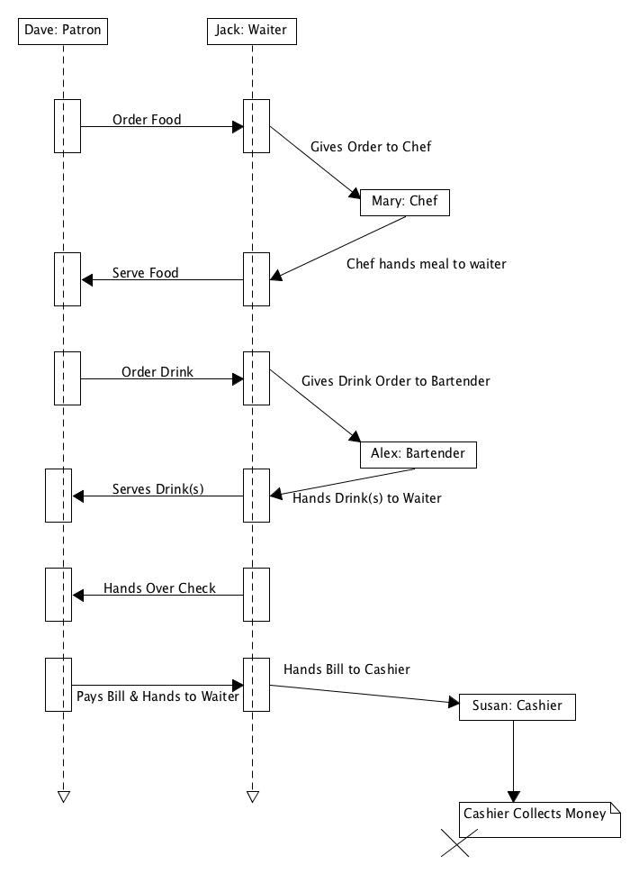Question 2 (Sequence Diagram):